ELEMENT ONE AND TWO NOT PART OF THIS TRAINING
ELEMENT THREE
ENGINEERING AND WORK PRACTICE CONTROLS WHICH REDUCE THE RISK OF WORKER EXPOSURE TO POTENTIALLY INFECTIOUS MATERIAL IN CHILD CARE SETTINGS
Introduction
Many factors influence the risk of worker exposure to potentially infectious agents including the physical structure of the facility, the availability of necessary resources for good hygiene (e.g., sinks for hand washing, disinfectants), and the age and health characteristics of children receiving services. Facility administrators should be knowledgeable of these factors and ensure that infection control policies and procedures are appropriate to the environment and efficacious in reducing exposures.
This element of the course presents information on environmental controls, specialized devices, and work practice techniques which significantly reduce the risk of exposure to infection.
Upon completion of this section, the learner will be able to:
- Define the terms “engineering controls” and “work practice controls”;
- Identify engineering controls and work practice controls which reduce the risk of exposure to infection;
- List exposure prevention strategies;
- Describe child care procedures and settings that involve an increased risk of exposure to infectious material.
What types of controls are available to protect children and adult caregivers from exposure to infectious material?
- Engineering controls – equipment and devices which minimize or remove infection hazards.
- Work practice controls - methods of task performance which reduce or eliminate the risk of exposure to infectious materials.
- Personal protective equipment - specialized clothing or equipment (such as gloves) worn by workers to reduce the risk of exposure to hazards.
What factors in a child care setting create an increased risk for exposure to infections?
Young children comprise the largest portion of the population present in the child care setting with the youngest children having the greatest susceptibility to infection. Infections acquired in child care settings are frequently transmitted person-to-person through direct and indirect contact with body substances such as feces, saliva, nasal secretions, and urine. Small children are unaware of the implications of recklessly touching and disposing of potentially infectious body substances. Adult caregivers are required to have repeated hands-on contact with children under hectic circumstances resulting in numerous opportunities for acquiring and spreading infections via contaminated hands. Incontinent children who are not toilet trained increase the risk of fecal contamination of hands and surfaces. Children naturally explore their environment with their hands and mouths resulting in exposure to secretions and excretions on contaminated objects and surfaces.
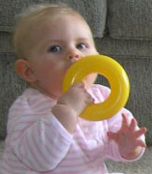
Many microorganisms associated with child care-related infections (such as CMV or rotavirus) can survive on environmental surfaces for considerable periods. Microbiological samples obtained in child care facilities demonstrated that the younger the population in the child care center, the greater the concentration of microorganisms on surfaces and in the air. Group A Streptococcus (GAS) was isolated from plastic toy “food” during an investigation of two cases of invasive GAS infections in a child care facility. These types of toys encourage mouthing behavior and are examples of fomites that contribute to transmission of infection.
Respiratory infections, transmitted through respiratory aerosols and droplets, are the most common infections associated with child care attendance. Studies in crowded homes and child care settings have shown that the risk of respiratory infections, including otitis media (ear infection), increases as the number of children per room increases.
Common source and foodborne transmission are rarely reported causes of outbreaks in child care settings. However, improper food handling practices have been shown to be a risk factor for illness spread by fecal-oral transmission in child care facilities.
What engineering controls are available for reducing exposure to infection?
Environmental controls assist in reducing the risk of cross infection. Infection prevention policies emphasize hand hygiene (the single most important measure for preventing the spread of infection). As such, it is practical to locate sinks close to areas where contamination of the hands is likely, such as near tables for changing diapers and near bathrooms. If alcohol-based, waterless antiseptic agents are used, the dispensers are best placed in locations where staff have limited access to sinks. It is important that staff recognize that hand gels are not a substitute for hand washing with soap and water when hands are visibly contaminated with body substances.
Diaper-changing surfaces must be constructed of nonporous material that can be cleaned with disinfectant between children. Using a disposable cover between children will provide an added barrier against environmental contamination. Diaper-changing surfaces must be kept clean and must never be in close proximity with food preparation areas. Small, child-sized flush toilets provide less of a hazard than potty chairs. Environmental surfaces that have been grossly contaminated with saliva, stool, or other body fluids must be cleaned immediately and disinfected.
Routine cleaning of all surfaces and toys is necessary even when gross contamination is not obvious. Non-washable toys must never be used.
Adequate ventilation is an essential part of reducing the transmission of airborne pathogens. The flow of fresh air through all child care areas serves to dilute the concentration of airborne pathogens and thus reduce the risk of infection from pathogen inhalation. Personal protective equipment such as gloves can be used to prevent contamination of hands with potentially infectious body fluids. This will be discussed in detail in Element 4.

Which work practice controls are effective for reducing exposure of patients and staff to infectious body fluids?
In addition to stringent monitoring and compliance with hand hygiene procedures, the following work practice controls can effectively reduce the risk of transmission of pathogens in child care settings.
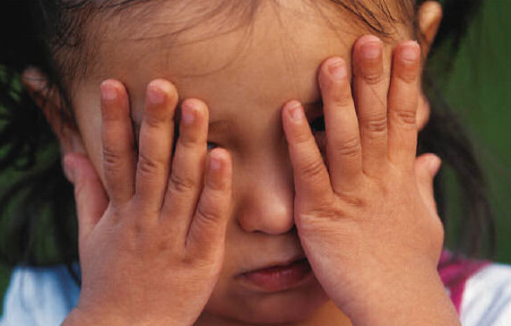
1. Rapid identification of suspected cases of infectious disease.
Rapid identification of disease will significantly reduce the risk of exposure to others. Child care professionals need to be knowledgeable of the symptoms of diseases which are prevalent in their community (e.g., tuberculosis, influenza). Rapid identification of airborne disease enables the timely removal from child care services thereby preventing transmission to other susceptible individuals. All child care facilities should have procedures in place for identification and management of children with communicable diseases.
A health check of each child must be performed every day upon arrival and continue throughout the day so that changes in the child’s behavior or appearance are detected. The child must be assessed for:
- Changes in behavior (such as lethargy or drowsiness) or appearance
- Skin pale or flushed, rashes, itchy skin; itchy scalp, or nits (during a lice outbreak)
- Elevated body temperature, if indicated
- Complaints of pain or of not feeling well, or child rubbing eyes, nose or mouth
- Other signs or symptoms of illness (such as drainage from eyes, vomiting, diarrhea, etc.)
- Reported illness or injury in child or family members since last date of attendance
2. Isolation of potentially infectious individuals from others at risk.
Children with suspected cases of diseases that are highly transmissible (particularly infections transmitted by airborne routes) can be separated from other susceptible individuals preferably in a separate room with good ventilation. The child must always remain under constant direct adult supervision until a responsible guardian arrives to remove the child from services.
3. Application of principles of respiratory hygiene.
Respiratory Hygiene / Cough Etiquette was incorporated into Standard Precautions as a practical approach to reducing the risk of airborne transmission of infectious agents such as M. tuberculosis bacteria, as well as pathogens transmitted via large respiratory droplets, such as influenza virus, adenovirus, Bordetella pertussis, Neisseria meningitides and Mycoplasma pneumoniae.
Respiratory hygiene entails instructing children and staff to cover their mouth with a tissue or with a shirt sleeve when coughing or sneezing - one of the most effective ways to control the spread of airborne pathogens. This simple practice reduces the number of airborne bacterial or viral particles, thereby decreasing the risk of transmission to all persons in the immediate area.
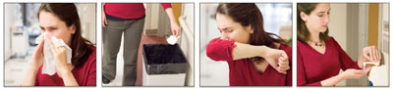
Staff and children can be instructed as follows:
- Cover your mouth and nose with a tissue when you cough or sneeze.
- If you don't have a tissue, cough or sneeze into your upper sleeve, not your hands.
- Put your used tissue in the waste basket.
- Clean your hands promptly after coughing or sneezing.
Administrators of child care facilities can promote respiratory hygiene by supplying tissues and a no-touch receptacle for disposal of contaminated tissues.
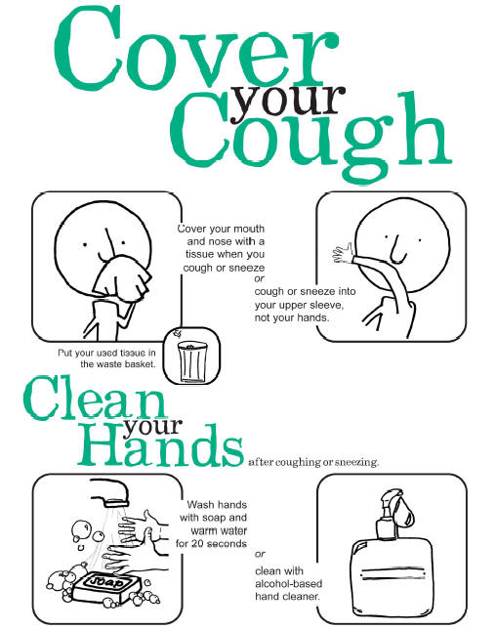

ELEMENT FOUR
SELECTION AND USE OF PERSONAL PROTECTIVE EQUIPMENT WHICH IS DESIGNED TO PREVENT WORKER CONTACT WITH POTENTIALLY INFECTIOUS MATERIAL AND APPLICATION OF STANDARD PRECAUTIONS IN A CHILD CARE SETTING
Introduction
Transmissible pathogens may be contained in human waste (urine, feces) and body fluids (saliva, nasal discharge, tissue and injury discharges, eye discharges, blood). Because many infected people are contagious before symptoms are present, staff members need to protect themselves and the children they serve by applying principles of Standard Precautions, using protective equipment, and carrying out environmental disinfection and sanitation procedures on a routine basis.
This section of the course provides information regarding the appropriate use of protective equipment in the child care setting as a means of reducing exposure to infectious pathogens.
Upon completion of this element, the learner will be able to:
- Define “Personal Protective Equipment”;
- Identify specific personal equipment that is used to protect workers from exposure to infectious pathogens;
- State specific circumstances that call for the use of gloves to prevent worker contact with potentially infectious material;
- Describe the procedure for removing contaminated disposable gloves from hands.
- Specify how Standard Precautions are applied in the child care setting to prevent exposure to infectious pathogens.
What is Personal Protective Equipment?
Personal protective equipment refers to specialized clothing and equipment worn by care providers for protection against hazards. In institutional care settings, the Occupational Safety and Health Administration (OSHA) requires employers to provide protective equipment to workers who are at risk of occupational exposure to potentially infectious materials.
What types of personal protective equipment are available?
In an out-of-home child care setting, workers may be exposed to body fluids of children when changing diapers, attending to wounds, assisting with toileting and when cleaning up environmental contamination. These types of activities are most likely to cause contamination of the hands. Therefore, for the care of children and their environment, the use of gloves can provide adequate protection for workers if used properly
What types of gloves are available?
Both sterile gloves and non-sterile gloves are commercially available. In child care settings, non-sterile gloves are appropriate. Sterile surgical gloves are used for performing procedures which involve direct contact with sterile body parts (e.g., surgical operations).
Non-sterile disposable gloves are used for performing procedures which may require contact with a body fluids, mucous membranes, or non-intact skin. Once they are used, they are readily discarded.
Non-sterile reusable utility gloves are made of thicker forms of rubber, latex or vinyl and are the best choice for decontaminating equipment, cleaning the environment, or removing waste.
Disposable gloves are constructed of latex, vinyl or nitrile polymers and may be powdered or powder-free. Utility gloves are generally made of rubber or latex. Facility administrators must be aware that gloves made of certain materials, such as latex, may cause allergic reactions. If workers or children are allergic to latex, hypo-allergenic gloves must be used in the facility. Providers who are allergic to powder can use powderless gloves.
HOW TO REMOVE DISPOSABLE GLOVES FROM HANDS
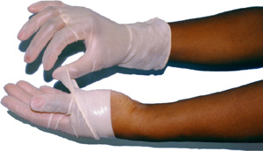 | 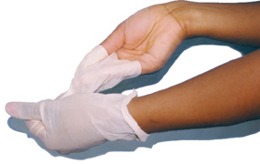
- Grasp the outside of the glove with the opposite gloved hand.
- Hold the removed glove in the gloved hand.
- Slide fingers of ungloved hand under remaining glove at wrist.
- Pull glove up and over the glove removed first.
When is it appropriate to wear protective gloves?
In line with Standard Precautions, it is appropriate for caregivers to use gloves for performing child care and sanitation procedures that carry a risk of acquiring infection through direct contact with blood; body fluids, excretions or secretions; mucous membranes, or non-intact skin (such as skin abrasions, rashes or open wounds). This concept expands upon the requirement put forth by Universal Precautions which requires the use of gloves only when exposure to blood is likely to occur.
Gloves must be removed immediately upon completing the dirty procedure and hand hygiene must be performed following glove removal. Gloves used for a procedure on one child must NEVER be used on another child.
If there is a risk of contact with large quantities of body fluid, two pairs of gloves (double gloving) can be used for additional protection.
Disposable gloves must not be worn unnecessarily for long periods of time. Doing so will increase the worker’s risk of infection, as the moist skin inside the gloves creates an environment that is conducive to the growth of bacteria. In addition, disposable gloves may develop small imperceptible holes through which pathogenic organisms may pass.
Note that in an emergency, a child’s well-being takes priority. A bleeding child must not be denied care even if gloves are not immediately available.
How are Standard Precautions implemented in a child care setting to prevent exposure to potentially infectious pathogens?
Caregivers should utilize Standard Precautions for every child and every situation where there is potential exposure to blood, body fluids, tissue discharges, and potentially infectious fluids.
Non-sterile disposable gloves and utility gloves provide adequate protection for the majority of situations with potential exposure to infectious fluids in a child care facilities. Gloves must always be promptly removed when the task is complete. Hand hygiene must always be performed when gloves are removed.
The caregiver’s clothing must be adequate to prevent small amounts of body fluids from soaking through to the skin. If clothing becomes contaminated with potentially infectious body fluid, it must be removed as soon as feasible, placed in a plastic bag, and separately laundered in detergent and hot water. For child care facilities with workers that have frequent exposure to body fluids through activities such as diapering, it may be advisable for administrators to provide smocks that can be worn over clothing and easily changed if contaminated. Disposable plastic aprons may also be useful for situations where there is a potential risk of clothing contamination, such as cleaning a large spill of body fluid.
To minimize contamination of the diaper changing table, a disposable moisture-resistant paper liner can be used for each diaper change. Paper that is used for one child must not be used on another.
Written procedures are a useful resource for staff who are required to manage spills of body fluids, urine, feces, vomitus, blood, saliva, nasal discharge, eye discharge, injury or tissue discharges.

ELEMENT FIVE
CREATION AND MAINTENANCE OF A SAFE ENVIRONMENT FOR CHILD CARE THROUGH THE APPLICATION OF INFECTION CONTROL PRINCIPLES AND PRACTICES FOR CLEANING AND DISINFECTION
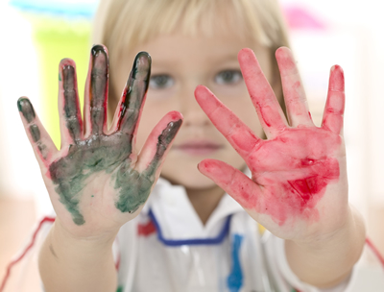
Introduction
Illnesses may be spread in a variety of ways, such as by coughing, sneezing, direct skin-to-skin contact, or touching a contaminated object or surface. Since children will touch any surface they can reach (including floors), all surfaces in a child care facility may be contaminated and have the potential to spread infectious disease agents. Respiratory tract secretions contain viruses (including respiratory syncytial virus and rhinovirus) that can remain infectious for variable periods of time when they contaminate environmental surfaces.
Regular and thorough cleaning of the environment can prevent the transmission of diseases in child care settings. This section of the course provides information regarding the proper disinfection of child care equipment and the maintenance of the child care environment.
Upon completion of this element, the learner will be able to:
- Specify procedures for disinfecting child care equipment which will effectively maintain the integrity of the equipment and assure child and staff safety;
- Define disinfection;
- State the procedure for cleaning spills of blood or body fluids.
- Discuss the use of bleach and other types of disinfectant solutions in the child care environment.
- List the important considerations of routine cleaning and sanitation in the child care setting.
Contaminated equipment and surfaces may expose children and staff to infectious pathogens. What factors may contribute to contamination?
- Inadequate cleaning.
- Inadequate sanitizing and disinfection.
- Contamination of the disinfectant solution.
What is the difference between sterilization and disinfection?
Sterilization is a process which completely eliminates all forms of microbial life.
Disinfection is a process which eliminates many or all pathogenic microorganisms which may be present on an inanimate object, with the exception of bacterial spores. (Some pathogenic bacteria become resistant to environmental forces by forming a hard external casing that permits the organism to survive under adverse conditions and in the presence of disinfectant solutions. These are known as “spores”. )
There are three levels of disinfection:
High level disinfection - elimination of all microorganisms, with the exception of large numbers of bacterial spores.
Intermediate level disinfection - elimination of specific organisms, i.e., Mycobacterium tuberculosis, vegetative bacteria, most viruses, and most fungi. Intermediate level disinfection does not eliminate bacterial spores.
Low level disinfection - elimination of most vegetative bacteria, some viruses, and some fungi. Low level disinfection cannot be relied upon to eliminate resistant microorganisms (e.g., tuberculosis bacteria, bacterial spores).
What is the most important element in the disinfection process?
Cleaning is the most important step in the sterilization and disinfection process. Cleaning refers to the removal of all foreign material (e.g., soil, organic material) from an object. There are several important points to be made regarding the cleaning process:
- The presence of foreign material will protect microbes from exposure to disinfectant solutions.
- Cleaning is best performed immediately after an item is contaminated to prevent foreign material from drying and adhering to the surface of the object.
- Physical cleaning of obvious contamination eliminates large numbers of microbes, thereby increasing the efficiency of the disinfection process.
The presence of obvious dirt on an item is an indication that the item is contaminated. An item cannot be considered disinfected if it has body substances encrusted onto it, even if the item has gone through a washing and disinfection process. Good physical cleaning of all gross soil is the most important part of the disinfection process.

What is the most common disinfectant solution used in day care settings?
Bleach solution is widely recommended for use in day care settings. Bleach is effective, economical, convenient, and readily available. Solutions of bleach and water are easy to mix, nontoxic, safe if handled properly, and are effective in eliminating most infectious agents.
The active ingredient in bleach is “sodium hypochlorite”. Companies that distribute bleach products (such as Clorox) manufacture household and industrial formulations which typically have concentrations of 5.25% sodium hypochlorite (regular strength) or 6.00% - 6.15% sodium hypochlorite (ultra strength).
Child care facilities are required to “sanitize” surfaces that are prone to contamination with potentially infectious material such as diaper changing surfaces, toys, or dining tables. Sanitizing is low level disinfection which renders most items safe for contact.
There are a number of products that advertise the ability to disinfect or “kill germs.” These types of products may kill bacteria and viruses but may not have the same effectiveness as recommended dilutions of bleach and water. Before using anything other than bleach for sanitizing, administrators must consult the regulations of the local health department or licensing authority. Products must always be verified as non-toxic for children and used according to the manufacturer’s instructions. The Environmental Protection Agency maintains standards for “hospital grade” disinfection solutions and publishes lists of approved disinfectant solutions. These lists can be found at the following website: http://www.epa.gov/oppad001/chemregindex.htm. When using an EPA-approved industrial product, always READ THE LABEL and follow the manufacturer’s instructions exactly.
Below is the label from the EPA-approved industrial brand of Clorox Ultra which is an intermediate level disinfectant that is active against Mycobacterium tuberculosis, HIV, Hepatitis B Virus, Hepatitis C Virus, Norovirus, Methicillin Resistant Staph aureus (MRSA), Vancomycin Resistant Enterococcus (VRE), and Influenza virus. The label clearly denotes the active ingredient as 6.15% Sodium Hypochlorite.
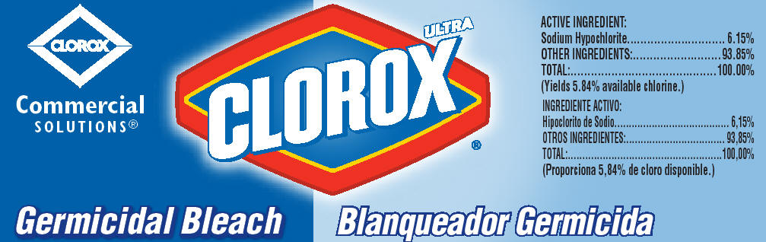
Household bleach products contain a minimum of 5.25% hypochlorite. Unlike industrial products, household bleach products are not likely to possess clear label instructions for disinfecting environmental surfaces as they are generally intended for use in laundry.
Acceptable sanitizing solutions can be prepared by mixing bleach (with a minimum of 5.25% sodium hypochlorite) and water in a spray bottle. Such solutions may be used to sanitize detergent-cleaned surfaces in bathrooms, diapering areas, countertops, tables, toys, door knobs and cabinet handles, phone receivers, hand washing sinks, floors, and surfaces potentially contaminated by body fluids.
Regulations and standards frequently use the term “parts per million” or “ppm” to specify the required concentration of sanitizing solutions made with bleach and water. Common household measurements can be used to mix sanitizing solutions that comply with the “ppm” standards.
TO SANITIZE | Mix this much  BLEACH | In this much  WATER | PPM if bleach bottle label shows 5.25% - 6.15% | Meets Standards that require | Instructions
Food contact surfaces (including counter tops, dining tables and high chair trays); and non-mouthed toys | ½ teaspoon | 1 quart | 137–160 ppm | less than 200 ppm | All surfaces must be cleaned with detergent and rinsed with water to remove any obvious soil. The surface should be sprayed until glistening and should be left for 2 minutes before wiping dry.
Diaper changing areas, surfaces contaminated with bodily secretions/excretions | 1 tablespoon | 1 quart | 820-961 ppm | minimum  500 ppm
Dishes, eating utensils and mouthed toys | 1 teaspoon | 1 gallon | 68-80 ppm | 50 – 100 ppm | All items should be washed with hot water, detergent, rinsed, and then submerged in bleach solution for at least five minutes.
Large spills of blood | 1 2/3 cup | 1 gallon | > 5,000 ppm | OSHA Standard | To be discussed.

Considerations and recommendations when using bleach:
- Bleach has an oily consistency and MUST be diluted with water in order for it to effectively coat and disinfect surfaces.
- Prior to disinfection with a bleach solution, items must be physically cleaned of all obvious contamination with a detergent solution.
- Never purchase a bottle of bleach that does not specify the concentration of sodium hypochlorite on the label.
- Bleach with added chemicals such as fragrances and thickeners can leave a residue and, therefore, is not appropriate for sanitizing or disinfecting surfaces in a child care setting.
- Open bottles of bleach should be discarded after 30 days.
- Bleach solutions must NEVER be mixed with other household chemicals such as toilet cleaners, rust removers, acids or products containing ammonia. (Read the label!) Mixing these chemicals with bleach will produce hazardous gases.
When preparing spray solutions of sanitizing bleach:
- Clearly label each spray bottle with the appropriate label. (See examples of labels below.)
- Prepare a fresh solution each day.
- Prepare solutions in a well-ventilated area using appropriate protective equipment (such as gloves) to avoid skin exposure.
- ALWAYS keep bottles out of the reach of children.
SAMPLE LABELS FOR SANITIZER BOTTLES
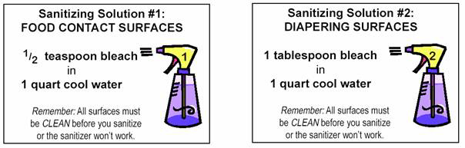
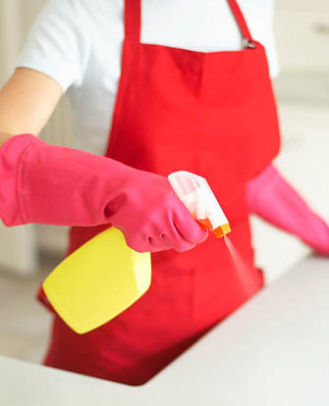
Are there special considerations for cleaning up spills of body fluids?
Small spills of body fluids (e.g. drops of blood, urine or stool) can be cleaned with detergent and water and then disinfected with the sanitizing solution of bleach (1 tablespoon of bleach in 1 quart of water) or an EPA-registered disinfectant that is listed as effective against tuberculosis bacteria (known as a “tuberculocidal disinfectant”). The bleach solution must be left in contact with the area of contamination for a full 2 minutes.
Bleach solutions and other germicides can become substantially inactivated in the presence of large quantities of blood and body fluids. Large spills of body fluids (such as accidentally spilling the entire fecal or urine contents of a potty on a floor) are effectively handled as follows:
Block off the area to prevent exposure to children and staff and gather necessary supplies including:
- absorbent material such a paper towels
- gloves – utility or 2 pairs of disposable
- detergent and disinfectant solution
- plastic bags for disposal.
For cleaning large spills, disinfecting solution can be an EPA-registered tuberculocidal disinfectant or a 1:10 solution of household bleach in water (i.e., 1 2/3 cup of bleach in 1 gallon of water).
Put on gloves to prevent contamination of hands. Utility gloves (e.g. rubber gloves) or disposable gloves may be used. Two pairs of thinner disposable gloves provide greater protection when cleaning rough surfaces.
Wipe up the spill using paper towels or absorbent material and place carefully in a plastic garbage bag. Take care to avoid splashing any contaminated material onto the mucous membranes of the eyes, nose or mouth. Be sure that non-intact skin, cuts or abrasions are fully covered and not exposed to the body fluid.
Wash the contaminated area with the detergent solution so that all visible soil is removed and wipe clean with disposable paper towels. Place contaminated paper towels into a plastic garbage bag.
Gently pour the 1:10 bleach solution onto all contaminated areas of the surface and let the solution remain in contact with the area for at least 10 minutes. If using an EPA-registered disinfectant other than bleach, follow the manufacturer’s instructions on the label.
After appropriate contact time, wipe up the remaining solution.
All non-disposable cleaning materials used to clean a body fluid spill - such as mops and scrub brushes – need to be washed with detergent, rinsed with clean water and disinfected by saturating the equipment with the 1:10 bleach solution for 10 minutes. Cleaning materials can be air dried.
If disposable gloves are used, remove gloves and place them in the plastic garbage bag with all soiled cleaning materials. Double-bag and securely tie-up plastic garbage bags and discard.
Thoroughly wash hands with soap and water.
For blood and body fluid spills on carpeting, put on gloves and use disposable paper toweling to blot body fluids from the fabric as quickly as possible. The soiled area can then be spot cleaned with a detergent solution followed by application of an EPA-registered tuberculocidal disinfectant. Bleach solutions may not be appropriate for carpeting. Additional cleaning by shampooing or steam cleaning by a professional cleaning service may be necessary. It is important to consult the manufacturer’s guidelines for both application of the disinfectant solution and cleaning of the carpeting.
All surfaces, furnishings, and equipment that are not in good repair or that have been contaminated by body fluids must be taken out of service until they are repaired, cleaned, and, if contaminated, sanitized effectively.

What are the important considerations of routine cleaning and sanitation?
Below is a sample schedule for routine cleaning of a child care facility. Cleaning schedules must be altered from the routine whenever there are outbreaks of illness or known contamination which require immediate action or increased frequency of cleaning procedures.
AREA | CLEAN | SANITIZE | FREQUENCY
Classrooms/Child Care/Food Areas
Countertops/tabletops, Floors, Door and cabinet handles | X | X | Daily and when soiled.
Food preparation & service surfaces | X | X | Before and after contact with food activity; between preparation of raw and cooked foods.
Carpets and large area rugs | X |  | Vacuum daily when children are not present. Clean with a carpet cleaning method approved by the local health authority. Clean carpets only when children will not be present until the carpet is dry. Clean carpets at least monthly in infant areas, at least every 3 months in other areas and when soiled.
Small rugs | X |  | Shake outdoors or vacuum daily. Launder weekly.
Utensils, surfaces and toys that go into the mouth or have been in contact with saliva or other body fluids | X | X | After each child's use, or use disposable, one-time utensils or toys.
Toys that are not contaminated with body fluids. Dress-up clothes not worn on the head. Sheets and pillowcases, individual cloth towels (if used), combs and hairbrushes, wash cloth and machine-washable cloth toys. (None of these items should be shared among children.) | X |  | Weekly and when visibly soiled.
Cubbies | X |  | Monthly and when soiled.
Linens, blankets, and bedding | X |  | Weekly, when visibly soiled, and before use by another child.
Hats | X |  | After each child's use or use disposable hats that only one child wears.
Cribs and crib mattresses | X | X | Monthly, before use by a different child, and whenever soiled or wet.
Phone receivers | X | X | Weekly.
Toilet and Diapering Areas
Handwashing sinks, faucets, surrounding counters, soap dispensers, door knobs | X | X | Daily and when soiled.
Toilet seats, toilet handles, door knobs or cubicle handles, floors | X | X | Daily, or immediately if visibly soiled.
Toilet bowls | X | X | Daily.
Changing tables, potty chairs (Use of potty chairs in child care is discouraged because of high risk of contamination). | X | X | After each child's use.
General Facility
Mops and cleaning rags | X | X | Before and after a day of use, wash mops and rags in detergent and water, rinse in water, immerse in sanitizing solution, and wring as dry as possible. After cleaning and sanitizing, hang mops and rags to dry.
Waste and diaper containers | X |  | Daily.

Adapted from Keeping Healthy, National Association for the Education of Young Children. 1999.
Walls, ceilings, floors, furnishings, equipment, and other surfaces must be in good repair, free from visible soil and in a clean condition. Carpets, porous fabrics, and other surfaces that trap soil and potentially contaminated materials must not be used in toilet rooms, diaper change areas, and areas where food handling occurs. Carpets and porous fabrics are not appropriate for some areas because they are difficult to clean and sanitize. Disease-causing microorganisms have been isolated from carpets.
Lice infestation, scabies, and ringworm are among the most common infectious diseases in child care. Toddlers often nap or sleep on mats or cots that are stored until nap time. Bedding (sheets, pillows, blankets, sleeping bags or mats) must always be constructed of a fabric that can be washed. Cross-contamination can occur if used bedding items are stored together so it is best to store each child's bedding in individually labeled bins, cubbies, or bags.

Are there special cleaning and disinfection procedures for toilet training equipment and bathrooms?
Potty Chairs
The use of potty chairs increases the risk of transmission of enteric pathogens because of the need for handling and cleaning after use. If potty chairs are used, they should be emptied into a toilet and cleaned and disinfected in a separate utility sink. If a utility sink is not available and it becomes necessary to wash the equipment in a sink that is also used for hand washing, the sink must be thoroughly cleaned with detergent and disinfected with bleach solution prior to use by any other individual. Equipment used for cleaning the potty chair (e.g. utility gloves, scrub brush) must also be sanitized.
It is best to use potty chairs that are constructed of plastic or nonporous synthetic material that can be scrubbed and withstand the corrosive actions of detergents and disinfectants. Wooden potty chairs remain porous even when the surface is coated with a finish and cannot be cleaned properly.
Equipment Used for Cleaning and Sanitizing
Equipment that is used for cleaning and sanitizing toileting facilities must never be used for other cleaning purposes. Rubber utility gloves designated for this purpose must be washed with soapy water and dried after each use.
Disposable towels are recommended for cleaning. The porous nature of sponges makes them difficult to clean and therefore should not be used.
Waste receptacles in toilet rooms must be well maintained and emptied daily. This practice prevents the spread of potentially infectious pathogens.
Are there special considerations for infant play areas?
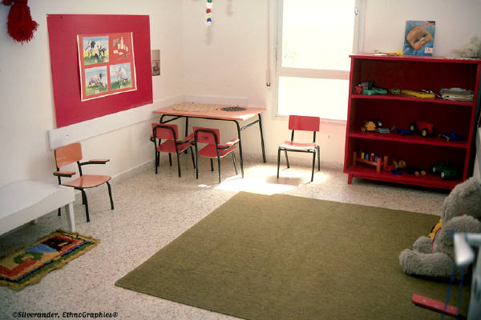
Shoes in Infant Play Areas
Infants and toddlers commonly touch the surfaces on which they play and then put their hands in their mouths. For this reason, contamination of floors is an important consideration in infant play areas. Shoes that have been worn in a toilet or diaper changing area, other play area, or outdoors, are potential sources of contamination to floors or surfaces where children are crawling and playing. It is advisable to designate a contained play surface for infant play on which no one walks with shoes. Individuals can wear special shoes or slippers that are worn only when entering the infant play area. Another approach is to place clean cloth or disposable shoe covers over shoes.
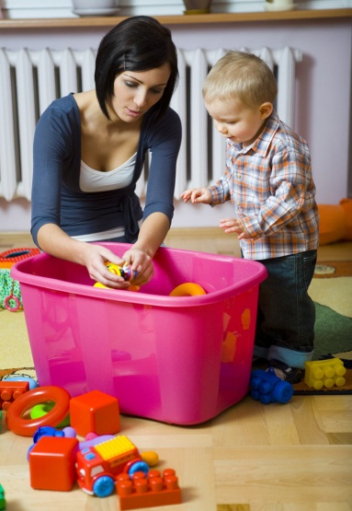
Use of toys that can be washed and sanitized
All toys can spread disease when children put the toys in their mouths, touch the toys after putting their hands in their mouths, or handle toys after toileting without adequate hand washing. Child care facilities must only use toys that can be washed and sanitized. If a toy becomes contaminated with a body secretion (including saliva), it must be removed from play until cleaned and disinfected. Toys that are used by one group of children must not be moved to another group unless washed and disinfected. Toys must be washed with hot water and detergent to remove gross soil and then sanitized with an appropriate disinfectant such as bleach solution.
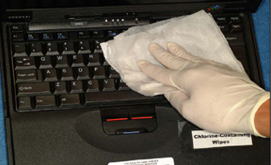
Computer keyboards
Computer keyboards used by multiple staff members and children have the ability to become contaminated by “touch”. Keyboards can be disinfected daily for 5 seconds and when visibly soiled. One study showed that commercial disinfecting wipes (Clorox wipes) were effective at removing 95% of bacteria from the keyboard (without any cosmetic damage after 300 wipes) and had a residual anti-bacterial effect for 48 hours.
Are there any special considerations for disinfecting items or surfaces contaminated with emerging pathogens like Influenza H1N1, MRSA or Clostridium difficile?
The standard cleaning and disinfection practices covered in this element are adequate to process objects contaminated with blood and other body fluids from persons infected with emerging pathogens. In instances where clusters of children and staff are found to be infected with Clostridium difficile or norovirus, environmental surfaces must be cleaned with a disinfectant known to be active against these agents – e.g., hypochlorite (bleach) solution in a 1:10 dilution. The manufacturer’s label on a container of industrial disinfectant solution will contain specific information regarding pathogens against which the chemical content is active.

PREVENTING AND CONTROLLING INFECTIOUS AND COMMUNICABLE DISEASES IN CHILD CARE WORKERS
Introduction
Child care providers, like health care providers, are at risk of acquiring infectious diseases in the workplace. Most child care providers are women, many of whom are child-bearing age. Some infections can pose a significant risk of adverse consequences for pregnancy outcomes. It is important for staff to be knowledgeable about infectious diseases that are common to child care settings and be able to assess circumstances where worker exposure to a pathogen requires prophylactic treatment in a timely manner.
Upon completion of this element, the learner will be able to:
- Recognize the importance of occupational health strategies which are designed to protect both child care workers and staff;
- Identify communicable diseases that are common in the child care setting;
- List reportable diseases and conditions and discuss the mechanism for reporting to the local health authorities;
- Recognize non-specific disease findings which require further evaluation of staff and children;
- Describe special considerations for identification and management of children with transmissible diseases and approaches to post-exposure management of child care staff and children.
Why are occupational health strategies so important?
Occupational health guidelines and regulations are intended to:
- protect workers from acquiring infectious or communicable diseases;
- prevent disease transmission by caregivers to children and other staff.
What immunizations are recommended for child care professionals?
Adult staff and volunteers at child care facilities can best protect themselves by being current for all immunizations recommended for adults by the Advisory Committee on Immunization Practices of the Centers for Disease Control and Prevention. These immunizations include the following:
(1) Measles, Mumps, Rubella (MMR): It is important for all persons who work in child care facilities to be immune to measles, mumps and rubella. Workers can undergo laboratory testing to verify immunity or provide documentation evidencing prior vaccination for these diseases.
(2) Diphtheria, Pertussis, Tetanus: It is recommended that child care workers be vaccinated with one dose of Tdap (tetanus toxoid, reduced diphtheria toxoid and acellular pertussis) to protect themselves, children, staff, family members and the community against tetanus, diphtheria, and pertussis. After initial vaccination, adults require a tetanus booster shot (0.5 ml) every ten years to ensure immunity.
(3) Hepatitis B Vaccine: OSHA requires that any worker who performs tasks involving potential contact with blood, blood-contaminated body fluids be vaccinated against hepatitis B.
(4) Influenza Vaccine: Influenza is a serious and potentially deadly disease that severely affects young children, the elderly and those with underlying medical conditions. Child care workers should strongly consider annual immunization for influenza because they have regular contact with a vulnerable population. Pneumococcal vaccine is also recommended in addition to influenza vaccine for people 65 years of age or older.
(5) Varicella Vaccine: It is recommended that all child care workers be immune to varicella. Evidence of immunity includes documentation of 2 doses of varicella vaccine given at least 28 days apart; a document evidencing history of varicella disease (chicken pox) or herpes zoster (shingles) based on physician diagnosis; or laboratory documentation showing immunity or confirmation of disease.
(6) Poliomyelitis Vaccine: Most adults do not need polio vaccine because they were vaccinated as children. Unvaccinated workers are at risk of acquiring the disease if exposed to the feces of an infected child.
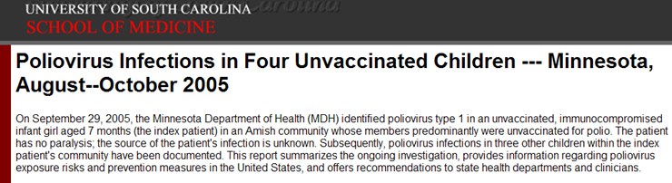
In addition to immunizations, it is important for all new staff to have a pre-employment health screening that includes:
- Results and any follow-up findings of tuberculosis screening (i.e Mantoux skin testing).
- A comprehensive review and certification of all vaccines.
- A review of occupational health concerns associated with job tasks.
- Assessment of risk from exposure to common childhood infections, such as parvovirus, cytomegalovirus (CMV), and chicken pox.
- Assessment of any potential communicable diseases that require accommodations or modifications for the person to perform job tasks.
At a minimum, all employees require a pre-employment physical to determine fitness for work. Documentation, such as a statement of good health, provided by a physician must be on file for each employee.

What are the basic principles for exclusion or dismissal of children with a potentially communicable disease?
For the protection of child care staff and children, any child exhibiting symptoms of a communicable disease requires an evaluation for potential exclusion from services. When a determination is made to dismiss a child because of a communicable disease, the parent or guardian must be promptly notified and advised to bring the child to their health provider for a complete medical evaluation. Parents must be instructed to report back to the child care facility if the medical evaluation reveals that the child has an infection that requires post-exposure precautions to prevent the spread of infection to others.
Below is a general list of exclusion criteria for ill children in out-of-home day care. All child care professionals should review their approved health care plan or seek the advice of the designated health consultant to ascertain the exclusion criteria that are specific to their program.
- Fever, defined by the child's age as follows:
  - Infants 4 months of age and younger: temperature ≥100°F axillary (armpit)
  - Children aged 4 months through 4 years: temperature ≥100°F axillary
  - Children older than 4 years of age: oral temperature ≥101°F or ≥100°F axillary
- Signs of possible severe illness, including unusual lethargy, irritability, persistent crying, difficult breathing, uncontrolled coughing.
- Diarrhea, defined as increased number of stools compared with the child's normal pattern, with increased stool water and/or decreased form.
- Blood in stools not explained by dietary change, medication or hard stools.
- Vomiting two or more times in the previous 24 hours unless the vomiting is determined to be due to a non-communicable condition and the child is not in danger of dehydration.
- Persistent abdominal pain continuing for more than 2 hours or intermittent pain associated with fever or other signs or symptoms.
- Mouth sores associated with an inability of the child to control his or her saliva, unless the child's physician or local health officer states the child is noninfectious.
- Rash with fever or behavior change until a physician has determined the rash to be non-communicable.
- Purulent conjunctivitis, defined as pink or red conjunctiva with white or yellow eye discharge, often with matted eyelids after sleep, and including a child with eye pain or redness of the eyelids or skin surrounding the eye.
- Infestation (e.g., scabies, head lice), until 24 hours after treatment has been initiated (head lice) or completed (scabies).
- Tuberculosis, until the child's physician or local health authority states the child is non-infectious.
- Impetigo, until 24 hours after treatment has been initiated.
- Streptococcal pharyngitis, until 24 hours after treatment has been initiated, and until the child has been without fever for 24 hours.
- Varicella, until 6 days after onset of rash or until all lesions have dried and crusted.
- Pertussis, laboratory-confirmed or suspected because of symptoms of the illness or because of cough onset within 14 days after face-to-face contact with a laboratory-confirmed case of pertussis in a household or classroom, until 5 days of appropriate chemoprophylaxis (currently erythromycin) has been completed.
- Mumps, until 9 days after onset of parotid gland swelling.
- Measles, until 4 days after onset of rash.
- Rubella, until 6 days after onset of rash.
- Hepatitis A virus infection, until 1 week after onset of illness or until after passive immunoprophylaxis (currently, immune serum globulin) has been administered to appropriate children and staff in the program, as directed by the responsible health department.
- Child is unable to participate comfortably in program.
- Care for the child requires greater attention than staff can provide without compromising the health and safety of other children.
Most children do not need to be excluded from child care when they have mild respiratory illness. Children with obvious signs of discomfort that interfere with their ability to participate comfortably in child care activities and those whose illness requires a level of attention by staff that may interfere with the care of other children may need to be sent home.
Isolation of a child is only used in certain circumstances, such as when an excluded child whose illness is considered to be contagious is waiting to be transported home, or when an included child needs a less stimulating environment than the child's usual care setting. Most ill children will rest in any setting if they are tired. A child must never be isolated in a closet, darkened room, or any area where the child cannot be seen and supervised.

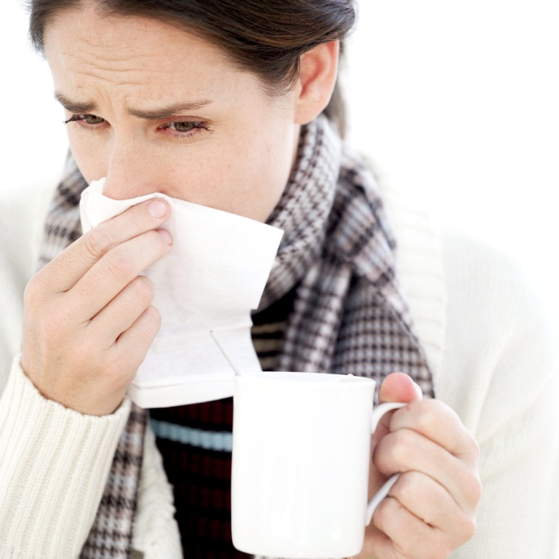
Are there criteria for exclusion of child care workers because of infection?
To protect themselves and the children in their care, adult caregivers with signs and symptoms of communicable disease should seek medical evaluation before reporting to work. With regard to bacterial and viral diseases, exclusion criteria are similar for children and adults with minor variations. For example, adults with “shingles” (a reactivation of the varicella virus that causes chicken pox) can continue to work if the lesions can be covered completely with clothing or until the lesions have crusted. Child care providers who have herpes cold sores need not be excluded from the child care facility if they are able to cover and not touch their lesions; carefully observe hand washing policies; and refrain from kissing or nuzzling infants or children.
What is the requirement for reporting diseases and conditions to local health authorities?
By reporting the occurrence of communicable diseases, local health authorities are alerted to the presence of potentially dangerous illnesses or outbreaks within the community. The information provided by child care professionals enables the authorities to quickly identify sources of the infection and initiate prophylactic measures to prevent the spread of the disease to children, staff, and family members who may have been exposed.
The designated health care consultant for a child care program can be contacted for situations that may require reporting, such as an outbreak or the presence of serious communicable diseases. The consultant can serve as an important resource by providing information; guiding the reporting process and assuring that all appropriate parties are informed.
Child care administrators have the following responsibilities when faced with the occurrence of a reportable communicable disease in their facility:
- Notify the local health department of known or suspected cases of reportable diseases associated with the facility.
- Consult with a health care provider or the local health department for post-exposure measures to control the spread of disease and protect those that have been exposed.
- Cooperate with public health authorities in the investigation of cases and suspected outbreaks of disease that may be associated with the child care facility.
- Establish and implement policies and procedures to maintain confidentiality related to medical information in their possession.
All local health authorities publish lists of diseases and conditions that must be reported. Vaccine preventable diseases generally require immediate reporting. This includes Diphtheria, Measles, Poliomyelitis, Mumps, Pertussis, Rubella, Chicken pox (Varicella) and Tetanus. Cases of suspected or confirmed contagious diseases with significant health risks, such as Meningococcal meningitis, must also be reported immediately by phone.
Child care administrators can acquire a list of reportable diseases and conditions from the local health authority. Staff should be knowledgeable about the exact procedure for reporting. The health department's list of communicable diseases can be posted in the facility as a reference along with phone numbers and contact information.
Below is a sample of the diseases and conditions that are reportable to the local health authority in New York City. Other cities and states have substantially similar lists and procedures. All diseases and conditions marked by the symbol ">>" require immediate reporting by phone.
Diseases and Conditions that Must Be Reported to the NYC Department of Health and Mental Hygiene
HIV/AIDS  • Diagnosis of HIV infection  • Diagnosis of HIV illness in a previously unreported individual (i.e.; HIV illness not meeting AIDS case definition)  • Diagnosis of AIDS-defining conditions  For assistance in reporting a case of HIV/AIDS, to receive the required NYS Provider Report Forms (PRF), or to obtain more information, please call 212-442-3388. NYS law also requires that PRFs contain names of sexual or needle-sharing partners of the infected person known to medical providers or those whom the infected person wishes to have notified of their possible exposures. Providers can utilize and/or refer HIV-infected persons to the NYC DOHMH Contact Notification Assistance Program (CNAP) at 212-693-1419 for assistance in carrying out partner notification.  Sexually Transmitted Diseases  FAX 212-788-4452  Chancroid  Chlamydia  Gonorrhea  Granuloma Inguinale (Donovanosis)  Herpes, Neonatal  (herpes simplex virus infection in infants age 60 days or less) with or without lab confirmation  Lymphogranuloma Venereum  Syphilis, including congenital syphilis  Tuberculosis  FAX 212-788-4179  • Positive AFB smears  • Positive nucleic acid amplification test for M. tb  complex  • Positive cultures for M. tb complex  • Continuation, discontinuation, completion, or other outcomes of treatment for active TB  • Susceptibility tests on M. tb cultures (5)  • Pathology findings consistent with TB  • Patients suspected of having TB  • Patients started on 2 or more anti TB drugs for the treatment of TB  • Any culture or NAA result associated with an AFB-positive smear (even if negative for M. tb complex (5))  • Child less than 5 yrs with a positive TST or bloodbased test for TB infection  Vaccine – Preventable Diseases  FAX 212-676-2300  >>Diptheria  >> Measles  Mumps (1)  Pertussis (1)  >> Poliomyelitis  Rubella, including congenital rubella syndrome (1)  Tetanus  >> Vaccinia disease (adverse events associated with  Smallpox vaccination)  Varicella Zoster virus (chickenpox) (5)  Other Reportable Communicable  Diseases and Conditions  FAX 212-788-4268  Amebiasis (1,2)  Anaplasmosis, formerly human granulocytic ehrlichiosis  >> Anthrax  >> Arboviral infections, acute  Babesiosis  >> Botulism  >> Brucellosis  Campylobacteriosis (1,2)  >> Cholera  Creutzfeldt-Jacob disease  Cryptosporidiosis (1,2)  Cyclosporiasis (1,2)  Dengue  Ehrlichiosis  Encephalitis (3) | Escherichia coli 0157:H7 and other Shiga toxin producing  E coli (1,2)  Giardiasis (1,2)  >> Glanders  >> Hantavirus disease  Hemolytic uremic syndrome  Hemophilus influenzae (invasive disease) (1)  >> Hepatitis A (1,2)  Hepatitis B, C, D, E  Hepatitis B cases in pregnant women must be reported on the IMM5 form or via Reporting Central. For more information, call 718-520-8245. Hepatitis, other suspected infectious  Hospital-associated infections  Influenza, lab confirmed (5)  >> Influenza, novel strain with pandemic potential  Influenza-related pediatric deaths (<18 years)  Kawasaki syndrome  Legionellosis  Leprosy (Hansen’s disease)  Leptospirosis  Listeriosis  Lyme disease  Lymphocytic choriomeningitis virus  Malaria  >> Melioidosis  Meningitis, viral (3)  Meningitis, bacterial  >> Meningococcal disease, invasive (1)  >> Monkeypox  Norovirus (5)  >> Plague  Psittacosis  >> Q fever  >> Rabies  Respiratory Syncytial Virus (RSV) (5)  >> Ricin  Rickettsialpox  Rocky Mountain spotted fever  Rotavirus (5)  Salmonellosis (1,2)  >> SARS (Severe Acute Respiratory Syndrome)  Shigellosis (1,2)  >> Smallpox  Staphylococcus aureus (methicillin resistant) (5)  Staphylococcus aureus, vancomycin intermediate (VISA)  >> Staphylococcus aureus, vancomycin resistant (VRSA)  >> Staphylococcal enterotoxin B  Streptococcal infection group A (invasive disease)  Streptococcal infection group B (invasive disease)  Streptococcus pneumoniae (invasive disease) (5)  Toxic shock syndrome  Trachoma  Transmissible spongiform encephalopathies  Trichinosis  >> Tularemia  Typhoid/Paratyphoid fever (1,2)  Vibrio species, non-cholera  >> Viral hemorrhagic fever  >> West Nile virus  >> Yellow fever  Yersiniosis (1,2)  Immunizations  Immunizations administered to children aged 18 years and younger must be reported to the Department. For information on how to report, please consult the website of the City Immunization Registry at www.nyc.gov/health/cir  Injuries  Animal Bites, FAX 212-676-0463  Reports are accepted via fax of Animal Report form VPHS-55, phone or Reporting Central.  >> Exposure to rabid or rabid-acting animal, or any rabies vector species (4)  Drownings, FAX 212-676-1517  Respiratory impairment from submersion/immersion in liquid. Drowning outcomes are classified as death,  morbidity, and no morbidity. | Falls, FAX 212 442-2629  Falls from windows of buildings with 3 or more  apartments, by children aged 10 years and younger  Poisonings  PHONE 212-764-7667, FAX 212-447-8223  Poisonings by drugs or other toxic agents including but not limited to pesticides and  >> Carbon monoxide  Lead Poisoning  FAX 212-676-6326, children 17 years and under  FAX 212-788-4299, adults  Blood lead levels of 10 mcg/dl or greater  Other Heavy Metal Poisoning  (Arsenic, Cadmium, Mercury)  FAX 212-788-4299  Food Poisoning (1,2)  FAX 212-442-3378  >> In a group of 2 or more persons  Sterilizations  Permanent sterilization procedures performed on both male and female patients must be reported to the Department. For information on how to report, call 212-442-1740.  Vital Events Certificates  All births, deaths, and spontaneous and induced  terminations of pregnancy must be reported to the Department using appropriate NYC certificates. To obtain blank certificate forms call 212-788-4520. To enroll in the Electronic Death Registration System, email: EDRS@health.nyc.gov  NOTES  (1) Report immediately by telephone a suspected case in a childcare, day care/group babysit, healthcare, nursing home, correctional, or homeless facility.  (2) Report immediately by telephone a suspected case in a food handler, child care worker, or health care worker.  (3) July 1-Oct 31: consider and test for West Nile virus.  (4) A bite or other (e.g, scratch) exposure to any animal confirmed to have rabies, or from any rabies vector species (raccoon, bat, skunk, fox or coyote), or any mammal exhibiting signs suggestive of rabies should be reported immediately. All other animal bites can be reported routinely via mail, telephone, fax or Reporting Central. If needed, consultation on management of animal bites and use of rabies post exposure prophylaxis is available on a 24/7 basis by calling the DOHMH contact numbers below.  (5) Reporting is only required through the Department’s Electronic Clinical Laboratory Reporting System and not by individual providers.  OUTBREAKS  Section 11.03(c) of the NYC Health Code requires the immediate reporting by telephone of a suspected outbreakamong 3 or more persons of any disease or condition(whether it is listed here or not), and of any unusual manifestation of disease in an individual.  During business hours call: 1-866-NYC-DOH1 (1-866-692-3641) for questions or forms. After business hours call: 212-POISONS (212-764-7667). To report online, visit Reporting Central at: www.nyc.gov/nycmed All results must be reported within 24 hours except where noted that immediate reporting is required. (>>)  >> Report suspected/confirmed cases immediately by calling 1-866-NYC-DOH1 during business hours or 212-764-7667 after hours.

When are parents notified about exposure of children to a communicable disease?
In cooperation with the local health authorities, it is important that parents are informed if their child has been exposed to a communicable disease at the facility. This includes (but is not limited to) the following diseases or conditions:
- Neisseria meningitidis (meningitis).
- Pertussis (whooping cough).
- Streptococcal infections such as Group A Streptococcal Infection.
- Varicella Virus (chicken pox).
- Skin infections (head lice, scabies, and ringworm).
- Transmissible infections of the gastrointestinal tract including hepatitis A virus.
- Haemophilus influenzae type b (Hib).
- Parvovirus B19 (Fifth disease).
- Measles.
- Tuberculosis.
The early identification and treatment of infectious diseases are important in minimizing the severity of the disease, as well as controlling the spread of disease to others. Notification of parents will permit them to discuss the implications of the exposure with their child's health provider and to closely observe their child for early signs and symptoms of illness.
Effective control and prevention of infectious diseases in child care depend on affirmative relationships between parents, caregivers, health departments, and primary health care providers.
Bottom of Form

Are there special considerations for specific communicable diseases in child care facilities?
Child care professionals are at risk for exposure to a number of communicable diseases because of the characteristics of the population they serve, the group dynamics and the environment. Adult workers can best protect themselves and the children in their charge by being knowledgeable about diseases prevalent in child care environments and their associated mechanisms of transmission and prevention.
The following is a listing of communicable diseases that are most likely to be associated with child care settings. Some of these diseases have serious health consequences and some may result in death. For each disease listed, the chart below describes:
- the mode of transmission, or exposure;
- recommendations for post-exposure treatment (i.e. prophylaxis) to prevent transmission or limit the severity of the disease;
- recommendations for employee exclusion from work and child exclusion from services.
DISEASES ASSOCIATED WITH THE RESPIRATORY TRACT
DISEASE | EXPOSURE | PROPHYLAXIS | EXCLUSION
Haemophilus Influenzae Type b (Hib) | Transmission occurs by inhalation of infectious droplets and contact with discharges of the nose and throat. | When two or more cases of invasive Hib disease have occurred within 60 days and unvaccinated or incompletely vaccinated children attend the childcare facility, giving rifampin to all childcare attendees and staff is indicated to prevent secondary spread of Hib disease. (Rifampin not recommended for pregnant women.) Non-immunized children should receive Hib vaccine. | All children who are not immunized with Hib must be excluded immediately and can return when the risk of infection is no longer present. This determination is usually made by the health department. Staff receiving prophylaxis need not be excluded from work.
Streptococcus  Pneumoniae  (Pneumococcus or Pneumococcal meningitis) | Transmission occurs by inhalation of infectious droplets; by direct contact with oral secretions; or by direct contact with articles that have been contaminated with respiratory discharges. | No specific recommendation for post-exposure antibiotic prophylaxis. | High risk children are assessed for immunization status with S. pneumoniae conjugate vaccine. Known cases must be excluded until deemed non-infectious by a health care provider or health authority.
Meningococcal meningitis  (Neisseria meningitides) | Transmission occurs by direct contact with respiratory tract secretions (including large droplets). | Exposed child care contacts may require chemoprophylaxis with rifampin or ceftriaxone as soon as possible to prevent an infection, preferably within 24 hours of diagnosis of the primary case. | All children and staff members for whom prophylaxis has been recommended must be excluded from attending the facility until these measures have begun. Any exposed individual who develops a fever must receive prompt medical evaluation. New entry children must not be enrolled in a child care facility in which a case of invasive N. meningitidis has been documented until 2 months has elapsed since the diagnosis was made.
Pertussis  (Whooping Cough) | Transmission occurs by direct contact with respiratory discharges from the mucous membranes of infected persons. | All staff members and children who have been exposed to infection should receive appropriate prophylactic treatment (i.e.,erythromycin, azithromycin, clarithromycin, or another appropriate antibiotic) and any additional treatment deemed medically necessary by a health care provider. | All exposed contacts must be excluded until they have received prophylactic antibiotic treatment. Upon return, all contacts must be monitored closely for symptoms for 20 days after the last contact with the infected person. Contacts with symptoms must remain excluded for 5 days after initiation of a 10-14 day course of antibiotic treatment. If antibiotic treatment is refused, the symptomatic contact must remain excluded for 3 -4 weeks after the onset of the cough.
Parvovirus B19  (Fifth Disease or Erythema Infectiosum) | Transmission occurs by direct contact with respiratory secretions, such as sharing drinking cups or utensils. | No specific recommendation for post-exposure anti-viral prophylaxis. | A person infected with parvovirus B19 is contagious before the rash appears. Therefore, the presence of a rash does not require exclusion.
Group A Streptococcus (GAS) | Transmission occurs by direct contact with mucus from the nose or throat of persons who are infected or through contact with infected wounds or sores on the skin. | No specific recommendation for post-exposure antibiotic prophylaxis. | Persons with group A streptococcal (GAS) respiratory tract, skin, or ear infections should be excluded until 24 hours after antibiotic treatment has been initiated and until the person is without fever for 24 hours. Consultation with the health department is advised when high rates of streptococcal infection occur in child care facilities.
Tuberculosis | Transmission occurs by inhalation of bacteria following prolonged exposure to the bacteria-laden aerosol produced when a person with contagious (active) pulmonary tuberculosis openly coughs or sneezes into the air. | Exposed contacts should be medically evaluated. Evaluation may include repeat TB skin testing, special blood tests, and chest x-ray. Anti-tuberculosis treatment (i.e., INH or isoniazid) may be prescribed. | Children and adult caregivers with documented pulmonary tuberculosis must be excluded until effective therapy has been instituted, adherence to therapy has been documented, and clinical symptoms have disappeared. Known cases must be assessed for potential to transmit disease by a health care provider or health authority.
Novel Influenza A (H1N1) | Transmission occurs through inhalation of virus-laden respiratory droplets and mucosal contact with infectious respiratory secretions. | Post exposure anti-viral chemoprophylaxis with either oseltamivir or zanamivir can be considered for those who are at high-risk for complications of influenza. Exposed staff and children should be referred to an appropriate medical provider for assessment and management. | Adult staff members and children should be excluded from the facility for at least 7 days from the onset of illness. Decisions about school and child care program closure are made by local authorities based on local considerations, including public concern and the impact of school or child care program absenteeism and staffing shortages.

Bottom of Form

Special considerations (continued)
DISEASES ASSOCIATED WITH THE HERPES VIRUS
DISEASE | EXPOSURE | PROPHYLAXIS | EXCLUSION
Herpes Simplex Virus  (Mouth sores) | Transmission occurs by direct contact with drainage from open sores and contaminated objects such as drinking cups or utensils. | No specific recommendation for post-exposure anti-viral prophylaxis. | Children with herpetic infection of the mouth who cannot control oral secretions may require exclusion from child care. Adult staff need not be excluded but must refrain from kissing and nuzzling children or sharing food and drinks with children and other caregivers; avoid touching the lesions; wash their hands frequently; and cover any skin lesion with a bandage or appropriate dressing.
Cytomegalovirus (CMV) | Transmission occurs by direct mucosal contact with infectious body fluids especially urine and saliva. | No specific recommendation for post-exposure anti-viral prophylaxis. Exposed pregnant workers should be referred to their physicians for management. | There are no specific requirements for exclusion of non-symptomatic staff or children who test positive for CMV. Facilities that employ women of childbearing age need to educate workers with regard to the increased probability of exposure to CMV in the child care setting; the potential for fetal damage when CMV is acquired during pregnancy especially among non-immune mothers; hand hygiene procedures and Standard Precautions.
Varicella-Zoster Virus  (Chicken pox) | Transmission occurs by inhalation of airborne viral particles that are carried on air currents from infectious skin lesions and respiratory secretions. | Susceptible staff members who are pregnant should be referred to health professionals who are knowledgeable in the area of varicella infection during pregnancy within 24 hours after the exposure is recognized. Varicella vaccine can be administered to non-pregnant susceptible persons 12 months of age and older within 72 hours after exposure to varicella. | Children who develop chicken pox must be excluded until all sores have dried and crusted (usually 6 days). Adult caregivers with mild cases of shingles (a reactivation of the zoster virus) do not require exclusion from work if lesions can be fully covered with clothing.

Chicken pox lesions | Herpes mouth sores

Special considerations (continued)
Intestinal pathogens are transmitted by the “fecal-oral” route meaning that disease-causing organisms from feces enter the body when they are ingested through the mouth. Adult caregivers have direct contact with feces during toileting or diaper changing activities or indirect contact with feces via contaminated surfaces. Ingestion of fecal pathogens occurs when contaminated hands touch items such as food or cigarettes that are subsequently placed in the mouth. Exposure to enteric pathogens is of significant concern in settings which involve children younger than 3 years of age who wear diapers.
DISEASES ASSOCIATED WITH THE INTESTINAL TRACT
DISEASE | EXPOSURE | PROPHYLAXIS | EXCLUSION
Enteric Infection with Hepatitis A | Viral pathogens are transmitted by the “fecal-oral” route (i.e., infectious fecal material enters the mouth). Ingestion of virus occurs when contaminated hands touch items such as food or cigarettes that are placed in the mouth. | Hepatitis A vaccine or Immune Globulin (IG) should be administered to all previously unvaccinated staff members and children of child care centers or homes if one or more cases of hepatitis A are recognized in children or employees; or cases are recognized in two or more households of center attendees. | Exclusion for hepatitis A virus is required for one week after onset of illness or until immune globulin or vaccine has been administered.
Enteric Infection with other pathogens | Enteric pathogens are transmitted by the “fecal-oral” route. | Common causative agents are rotavirus or other enteric viruses; Shigella, Giardia lamblia, or Cryptosporidium. There are no specific recommendations but a health care professional should be always consulted when an organism is identified. | Children with diarrhea will require exclusion if the child is unable to use a toilet; the diarrhea is accompanied by jaundice; and stool specimens indicate the presence of a pathogenic organism as confirmed by a licensed health care professional. Adult staff and children who excrete intestinal pathogens but do not have diarrhea may be allowed to return to child care except for the case of infections caused by Shigella, E. coli 0157:H7 or Salmonella typhi. For Shigella and E.coli 0157:H7 two negative stool cultures are required for readmission, unless state requirements differ. For Salmonella typhi, three negative cultures are required

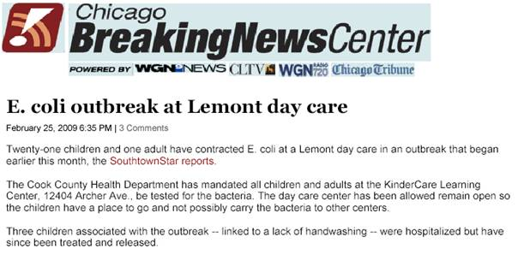

Special considerations (continued)
DISEASES ASSOCIATED WITH THE SKIN AND HAIR
DISEASE | EXPOSURE | PROPHYLAXIS | EXCLUSION
Scabies | The microscopic scabies mite burrows into the upper layer of the skin where it lives and lays eggs. Transmission occurs by prolonged skin-to-skin contact with a person who has scabies. | Caregivers who have had prolonged skin-to-skin contact with infested persons may benefit from prophylactic treatment with prescription medications and should be referred to a physician for management. Bedding and clothing that is worn directly against the affected skin should be washed in hot water and detergent. | Adult staff and children must be excluded from the facility until scabies treatment is completed. Scabicides used to treat human scabies are available only with a doctor’s prescription.
Head Lice | Spread by direct contact with the hair of an infested person. | There is no specific post-exposure prophylaxis. Children and staff who have been in close contact with an affected child should be closely examined and treated if infested. The environment should be vacuumed thoroughly; clothing, bed linens, and other items worn by the infested person should be washed in hot water and placed in a dryer with high heat. | After proper application of an appropriate over-the-counter pediculicide (lice medicine), a child or staff member may return to the premises. Parents of affected children must be told that their child must be treated properly before returning to the child care facility the next day. A second treatment with pediculicide is recommended after 9-10 to kill any surviving hatched lice before they produce new eggs.
Ringworm  (Tinea, fungus infection) | Fungus is transmitted by direct contact with the scalp or body of an infected person and by contact with the skin of infected animals. | No specific recommendation for post-exposure prophylaxis. | Adult staff and children with ringworm of the scalp or body require appropriate treatment and do not require exclusion while receiving treatment.

SCABIES | LICE
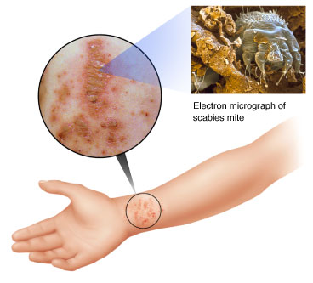 | 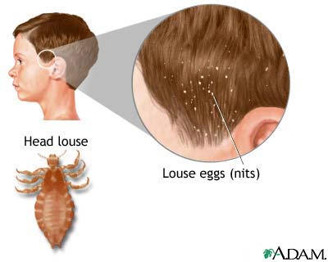
RINGWORM
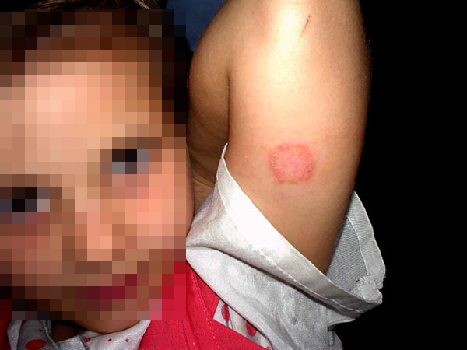

Special considerations (continued)
DISEASES ASSOCIATED WITH BLOOD AND BODY FLUIDS
DISEASE | EXPOSURE | PROPHYLAXIS | EXCLUSION
Hepatitis B Virus | The virus is transmitted when blood or infected body fluid penetrates the skin or mucous membranes and enters the bloodstream. Routine childhood immunization has decreased the number of susceptible children thereby reducing the potential for transmission. | Any person who has sustained an exposure to blood or potentially infected body fluids should be immediately referred to a health provider or emergency room for evaluation. Prophylactic treatments (i.e., Immune Globulin, vaccine) are available to exposed persons. These treatments are most effective when administered as soon as possible after an exposure. | Exclusion from the facility is not required because the risk of disease transmission from a child or staff member carrying hepatitis B virus is very low if the individual does not have behavioral risk factors or bleeding problems. A child with aggressive behavior (such as biting or frequent scratching) who is a known hepatitis B virus carrier may require evaluation by the child's health care provider or the health department to determine the child's continuing attendance in the facility.
Hepatitis C Virus | The virus is transmitted when blood or body fluid penetrates the skin or mucous membranes and enters the bloodstream. | There is currently no recommended post-exposure prophylactic treatment for Hepatitis C. An exposed worker should be referred to a physician or emergency room to receive baseline blood testing for Hepatitis C antibodies. There are currently several treatments approved by the FDA for treatment of HCV. | Similar to hepatitis B virus, a child with aggressive behavior (such as biting or frequent scratching) who is a known HCV carrier may require evaluation by the child's health care provider or the health department to determine the child's continuing attendance in the facility.
Human Immuno-deficiency Virus (HIV) | The virus is transmitted when blood or body fluid penetrates the skin or mucous membranes and enters the bloodstream. No reported cases of HIV infection are known to have resulted from transmission in out-of-home child care. | An exposed worker or child should be referred immediately to a health care provider (or hospital emergency room). Post-exposure prophylaxis with anti-viral medications should be initiated as soon as possible, ideally within 2 hours and generally no later than 36 hours post-exposure. The prescribing provider should ensure that the exposed worker has access to the full course of prophylactic antiretroviral medications. | Children infected with HIV can be admitted to child care provided that their health, neurological development, behavior, and immune status are acceptable, as determined on by a qualified health practitioner. Similarly, there are no restrictions for employment of HIV-infected adult staff members. The risk of transmission of HIV and other bloodborne viruses is minimized by adhering to Standard Precautions. Children and staff with compromised immune systems must be referred to their health provider following any exposure to highly contagious viral disease such as measles or chicken pox.

What is the risk of acquiring a bloodborne pathogen in the child care setting?
The risk of transmission of Hepatitis B Virus (HBV) in the child care setting is very small. Children and adults who are born in countries where HBV is prevalent may be carriers of the virus. Regions of the world with high or intermediate prevalence of HBV carriers include much of Eastern Europe, Asia, Africa, the Middle East, and the Pacific Islands. The virus is transmitted when blood or body fluid penetrates the skin or mucous membranes and enters the bloodstream. Routine childhood immunization has decreased the number of susceptible children thereby reducing the potential for transmission.
Transmission risks of Hepatitis C Virus (HCV) infection in a child care setting following percutaneous exposure (infected blood that passes through the skin into the bloodstream) or contamination of mucous membranes is extremely low. Health care workers who were injured with sharp objects (e.g. a needle or scalpel) contaminated with infected blood from a known HCV patient acquired the infection at a rate of 1.8% (less than 2 out of 100 persons exposed). There have been no documented cases of transmission to a health care worker following non-intact skin or mucous membrane exposures to blood.
Human immunodeficiency virus (HIV) is known to be transmissible through occupational exposure in health care settings. Although HIV can be found in body fluids other than blood, occupational transmission has occurred almost exclusively through direct contact with infected blood. The risk of transmission varies with the type and severity of exposure to known HIV-infected blood or body fluid is as follows:
- Percutaneous exposure such as being stuck with a blood-contaminated needle or cut with a device visibly contaminated with blood --- Risk is 0.3% (approximately 1 in 300).
- Exposure by blood splashing into eye, nose or mouth – Risk is 0.09% (approximately 1 in 1,000).
- Exposure by blood coming in contact with open skin wounds – Risk is less than 1 in 1,000.
No reported cases of HIV infection are known to have resulted from transmission in out-of-home child care.
Transmission of bloodborne pathogens in a child care setting is most likely to occur through direct exposure via bites or scratches that break the skin and introduce blood or body secretions from a carrier of the virus into the victim. Bloodborne viruses can also be passed if an unhealed open wound becomes contaminated with blood or body fluids from the infected person. Saliva contains much less virus (1/1000) than blood; therefore, the potential infection from saliva is low.
A child with aggressive behavior (such as biting or frequent scratching) who is a known carrier of a bloodborne virus may require evaluation by the child's health care provider or the health department to determine the child's continuing attendance in the facility.

What is the appropriate action to take if a child or staff member becomes exposed to blood or visibly bloody body fluids?
Wound and skin sites exposed to blood must be cleansed with soap and water immediately. Mucous membranes exposed to blood must be immediately flushed with water.
Post-exposure prophylaxis (PEP) is recommended for exposure to blood or visibly bloody fluid in any of the following exposure situations:
- Break in the skin by a sharp object that is contaminated with blood or visibly bloody fluid.
- A skin-penetrating bite from a child with visible bleeding in the mouth.
- Splash of blood or visibly bloody fluid to a mucosal surface (mouth, nose, or eyes).
- Exposure of non-intact skin (e.g., dermatitis, chapped skin, abrasion, or open wound) to blood or visibly bloody fluid.
An exposed worker or child must be referred immediately to a health care provider (or hospital emergency room). If post-exposure treatment is indicated, medication must be initiated as soon as possible, ideally within 2 hours and generally no later than 36 hours post-exposure. The prescribing provider must ensure that any worker exposed to HIV infection has access to the full course of prophylactic antiretroviral medications.
Child care facility administrators must consult with local health authorities on the requirements to report cases of HIV infected children and staff and the requirements to report occupational exposures.
It is important for administrators of child care facilities to have access to a health consultant—usually a physician or nurse with expertise in children's health—who can provide advice and assistance with infection control and health issues. Public health authorities also provide valuable guidance and education in situations involving communicable disease.
Bottom of Form

What is the single most important measure in preventing infection?
Hand hygiene
Pathogenic organisms are most effectively spread on the contaminated hands of children and adult caregivers. Proper hand hygiene is the most effective way to reduce the spread of infection in child care settings.
In January 2002, the American Academy of Pediatrics and the American Public Health Association published the 2nd edition of health and safety performance standards for out-of-home child care. These standards recommend that hand hygiene be performed:
- Upon arrival for the day or when moving from one child care group to another.
- Before and after eating, handling food, or feeding a child, giving medication, or playing in water that is used by more than one person.
- After:
  - Diapering
  - Using the toilet or helping a child use a toilet
  - Handling bodily fluid (mucous, blood, vomit); secretions from sneezing, wiping noses and mouths; or drainage from sores.
  - Handling uncooked food, especially raw meat and poultry
  - Handling pets and other animals
  - Playing in sandboxes
  - Cleaning or handling the garbage
Studies have shown that diarrheal illness and colds are greatly reduced when staff are closely monitored for their compliance with frequent and proper hand hygiene practices.
What is the proper way to clean the hands?
Hand washing instructions: Wet the hands with warm running water. Apply soap and work up lather for 15 - 30 seconds, while rubbing all surfaces of the hands. Pay close attention to washing between fingers, around nail beds, and underneath the nails.
Duration of washing is important to assure mechanical removal of debris and allow antibacterial soap solutions (if used) sufficient contact time to achieve the desired effect.
After washing the hands, use a paper towel to turn off the water tap. Do not touch the water tap with freshly washed hands as this will result in re-contamination of the skin. Many sinks are equipped with wrist blades, foot pedals, or automatic water flow sensors. Such devices provide for more sanitary water delivery.
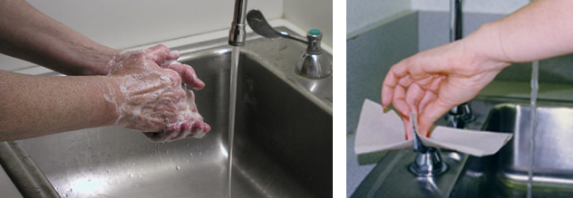
Staff members with long fingernails need to be especially careful about proper hand washing, since microorganisms can live beneath the nails. Artificial nails and chipped nail polish are known to support the growth of large numbers of bacteria. It is good practice to keep natural nails less than one quarter of an inch in length. Furthermore, it is good practice to avoid wearing jewelry, such as rings and bracelets, which may easily harbor infectious agents. If jewelry is worn, it should be removed before washing so that all areas of the skin can be properly cleansed. Jewelry should be scrubbed with soap and water before returning it to freshly cleaned hands.

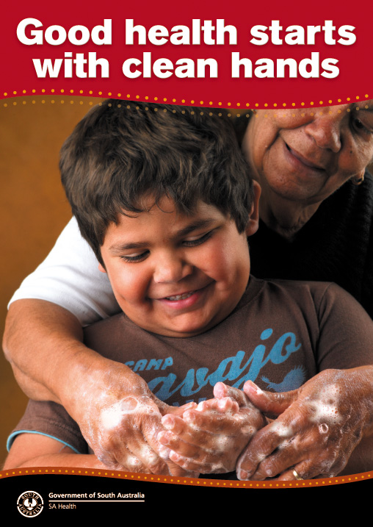
Sinks for hand washing are best located as close as practicable to children’s playrooms and classrooms and installed at a height that allows unassisted use by children. A child who is able to stand may use a child-size sink or stand on a safety step at a height that permits the child’s hands to hang freely under the running water. All sinks must be equipped with soap and individual paper towels that are located within easy reach of the children.
Caregivers will need to provide assistance for children who cannot wash their hands independently. After assisting the child with hand washing, the staff member must wash his or her own hands. Encouraging and teaching children good hand washing practices must always be done in a safe manner. Washing the hands of infants with warm water and soap (while the infant is safely cradled in the caregiver’s arms) is very effective in reducing the spread of infection.

If a child is unable to stand at the sink and is too heavy to hold safely, caregivers should use the following method to wash the child’s hands:
- Wipe the child’s hands with a damp paper towel moistened with a drop of liquid soap. Then discard the towel.
- Wipe the child’s hands with a clean, wet, paper towel until the hands are free of soap. Then discard the towel.
- Dry the child’s hands with a clean paper towel.

What kind of soap should be used to wash the hands?
Sinks equipped with liquid soap are the best option for child care facilities. Adequately drained bar soap has never been implicated in the transmission of infection in group settings; however, bar soaps sitting in pools of water have been cultured and shown to be heavily contaminated with Pseudomonas and other bacteria. Also, children often do not have the dexterity to handle a bar of soap.
Child care facility administrators can choose from an array of antibacterial and plain liquid soap products. Frequent use of antibacterial soaps is known to be more irritating to skin than plain soap. To promote compliance with hand hygiene procedures, it is important that staff members be satisfied with the soap that is provided. Adult staff will be less inclined to use a product that creates skin irritation. The cost of the product is often another consideration for administrators.
Dispensers used for liquid soap can develop caking around the delivery spout. Such residue can become a reservoir for infectious agents. Also, “topping off” or adding liquid soap to a partially empty soap dispenser can lead to bacterial contamination of soap.
Waterless alcohol-based antiseptic hand gels have grown in popularity because they may conveniently placed in areas where sinks and plumbing are not present. Recent research has shown that these formulations can be more effective than antimicrobial soap in reducing bacterial counts on the hands thereby preventing the transmission of potentially harmful bacteria in institutional settings. Some studies have demonstrated that skin dryness caused by alcohol-based solutions is equivalent to or less severe than dryness caused by standard antibacterial hand washing solutions.
There are several important considerations before implementing an alcohol-based hand washing system.
- Alcohol-based solutions are flammable and must be stored appropriately.
- Alcohol-based formulations vary in consistency, fragrance, skin conditioning agents, and drying time. These factors may influence staff acceptance and use of the product.
- Similar to other hand washing products, dispenser systems vary and may be prone to problems such as clogging.
- Alcohol-based gels and rinses may be more expensive than other types of antiseptic hand washing solutions.
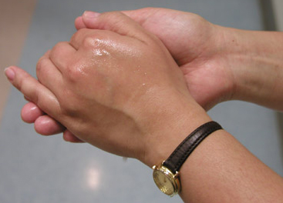
Alcohol handrub procedure: When using an alcohol-based handrub, apply the product to the palm of one hand and rub both hands together, covering all surfaces of hands and fingers, until hands are dry. Note that the volume needed to reduce the number of bacteria on hands varies by product.
An alcohol-based handrub should not be used if hands are visibly dirty or contaminated with blood or body fluids.
Hands that are visibly contaminated must be washed well with soap and warm water. After hand washing is complete, the alcohol-based gel can be applied.
Before implementing any new system of hand washing, it is good practice to have staff perform a thorough evaluation of the product. Staff acceptance will facilitate compliance with hand washing protocols.

What else can a child care professional do to break the chain of infection?
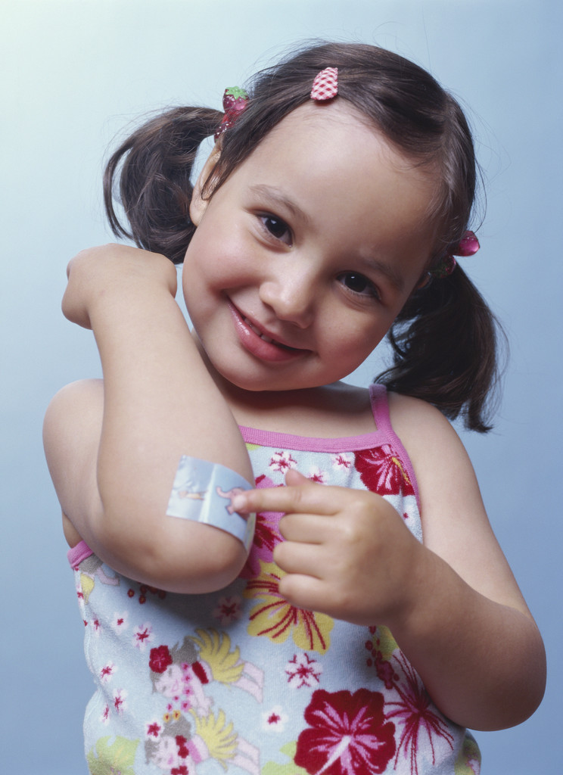
Standard Precautions are infection prevention strategies based on the principle that all blood, body fluids, secretions, excretions (except sweat), non-intact skin, and mucous membranes may contain transmissible infectious agents. These precautions are intended to apply to all children and staff, regardless of suspected or confirmed infection status. The application of Standard Precautions is strongly endorsed by the Centers for Disease Control and Prevention as the primary means of reducing the risk of occupational exposures to pathogens in institutional care settings. Universal Precautions are practices recommended by the Occupational Safety and Health Administration (OSHA) as part of the OSHA Bloodborne Pathogens Standard. By definition, these practices only apply to pathogens transmitted by contact with blood. Standard Precautions include and expand protection beyond Universal Precautions as they consider occupational exposure to all types of body fluids capable of transmitting pathogenic organisms.
Infection prevention practices include hand hygiene and the use of gloves for potential contact with body fluids, mucous membranes, draining wounds or non-intact skin. A secure waterproof bandage will protect an open wound or non-intact skin from direct contamination with dangerous pathogens. Placing a dry dressing on fresh cuts or sores will prevent contamination of surfaces with wound drainage.
Standard Precautions also requires that contaminated items in the child care environment be handled in a manner to prevent transmission of infectious agents (e.g., wear gloves for direct contact with heavily soiled items; properly clean and sanitize toys).
In health care settings, providers frequently have direct contact with individuals who harbor communicable diseases and have a greater likelihood of occupational exposure to large amounts of infected body fluids. Invasive procedures performed in the health care setting further increase the risk that clinical staff will be exposed to blood and body fluids of patients. For this reason, health care practitioners are trained in the use of impervious gowns, specialized masks, eye protection and face shields, which are not essential for the types of exposures that routinely occur in out-of-home child care settings.
Transmission-Based Precautions are utilized in health care settings for patients who are known or suspected to be infected with infectious agents (such as antibiotic resistant organisms) which require control measures in addition to Standard Precautions to effectively prevent transmission. There are three categories of Transmission-Based Precautions: Contact Precautions, Droplet Precautions, and Airborne Precautions. For diseases that have multiple routes of transmission (e.g., SARS), more than one Transmission-Based Precautions category may be used. When used either singly or in combination, they are always used in addition to Standard Precautions.
In the child care setting, Transmission-Based Precautions cannot be fully instituted to prevent transmission of disease. As a result, children with infections requiring more sophisticated precautions are excluded from child care service until they have entered a non-infectious stage of the disease.
Contact Precautions are intended to prevent transmission of infectious agents which are spread by direct or indirect contact with the infected person or their environment; and where the presence of excessive wound drainage, fecal incontinence, or other discharges from the body suggest an increased potential for extensive environmental contamination and risk of transmission. Pathogens transmitted by contact include MRSA (Methicillin Resistant Staph aureus), VRE (Vancomycin Resistant Enterococcus species), and Clostridium difficile.
Droplet Precautions are intended to prevent transmission of pathogens spread through respiratory or mucous membrane contact with respiratory secretions. Infectious agents for which Droplet Precautions are indicated include B. pertussis (whooping cough), influenza virus, adenovirus, rhinovirus, N. meningitides, and group A Streptococcus (for the first 24 hours of antimicrobial therapy).
Airborne Precautions prevent transmission of infectious agents that can be spread over long distances by remaining suspended in the air (e.g., measles virus, varicella virus, M. tuberculosis, and possibly SARS-CoV). Hospitalized patients with airborne disease are placed airborne infection isolation rooms that have special air handling and ventilation capacity.

TABLE 1: Common Pathogens and their Mode of Transmission in Child Care Facilities
MODE | VIRUS | BACTERIA | PARASITE / FUNGAL
Fecal-oral-contact transmission | - Rotavirus  - Hepatitis A  - Enteroviruses  - Enteric adenovirus  - Calicivirus  - Astrovirus | - Shigella  - Campylobacter  - E coli 0157:H7  - Salmonella  - C difficile  - Aeromonas | - Giardia lamblia  - Cryptosporidium  - Enterobius vermicularis
Respiratory-airborne transmission | - Influenza  - Varicella Zoster  - Measles | - M tuberculosis
Respiratory-droplet transmission | - Influenza  - Adenovirus  - Repiratory Syncytial Virus (RSV)  - Measles  - Rhinovirus (common cold)  - Parvovirus B19  - Mumps  - Rubella | - Haemophilus influenzae  - Neisseria meningitidis (Bacterial meningitis)  - Pertussis (Whooping cough)  - Diphtheria (pharyngeal)  - Mycoplasma pneumonia  - Streptococcal pharyngitis, pneumonia,or scarlet fever
Respiratory-contact transmission | - Rhinovirus  - Enterovirus  - Parainfluenza  - RSV
Direct-person-to-person or fomite-contact transmission | - Herpes simplex  - HIV  - Hepatitis B  - Cytomegalovirus (CMV)  - Viral conjunctivitis | - Group A (skin) Streptococcus  - Staphylococcus aureus | - Scabies  - Pediculosis (Lice)  - Tinea capitis (Ringworm-scalp)  - Tinea corporis (Ringworm-skin)

Other important measures for reducing the risk of disease transmission include:
- Verifying compliance with childhood vaccination. All children enrolled in child care are required to have age-appropriate immunization for diphtheria, tetanus, pertussis, poliomyelitis, measles, mumps, rubella, varicella, hepatitis B and Haemophilus influenzae type b. Exceptions to the vaccination requirement may occur. Administrators should refer to State regulations for detailed information regarding this requirement.
- Verifying immunizations for adult child care staff and volunteers.
- Effective housekeeping procedures; appropriate ventilation; safe handling of visibly contaminated linen and potentially infectious waste.
- Assuring worker and child protection through availability of post-exposure treatment.
- Training and education of child care staff and parents to ensure understanding of concepts in disease transmission and methods to reduce the risk of transmission.
REMEMBER: Whatever precautions may be taken, PROPER HAND HYGIENE is the MOST EFFECTIVE way to reduce the spread of infection.

What engineering controls are available for reducing exposure to infection?
Environmental controls assist in reducing the risk of cross infection. Infection prevention policies emphasize hand hygiene (the single most important measure for preventing the spread of infection). As such, it is practical to locate sinks close to areas where contamination of the hands is likely, such as near tables for changing diapers and near bathrooms. If alcohol-based, waterless antiseptic agents are used, the dispensers are best placed in locations where staff have limited access to sinks. It is important that staff recognize that hand gels are not a substitute for hand washing with soap and water when hands are visibly contaminated with body substances.
Diaper-changing surfaces must be constructed of nonporous material that can be cleaned with disinfectant between children. Using a disposable cover between children will provide an added barrier against environmental contamination. Diaper-changing surfaces must be kept clean and must never be in close proximity with food preparation areas. Small, child-sized flush toilets provide less of a hazard than potty chairs. Environmental surfaces that have been grossly contaminated with saliva, stool, or other body fluids must be cleaned immediately and disinfected.
Routine cleaning of all surfaces and toys is necessary even when gross contamination is not obvious. Non-washable toys must never be used.
Adequate ventilation is an essential part of reducing the transmission of airborne pathogens. The flow of fresh air through all child care areas serves to dilute the concentration of airborne pathogens and thus reduce the risk of infection from pathogen inhalation.
Personal protective equipment such as gloves can be used to prevent contamination of hands with potentially infectious body fluids. This will be discussed in detail in Element 4.

